Query1: List of all patients and their phone numbers

Query 2: List of all doctors with their department name
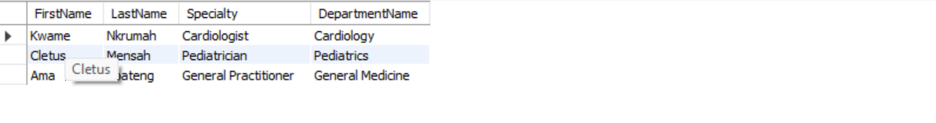
Query 3: Show all appointments with patient and doctors name
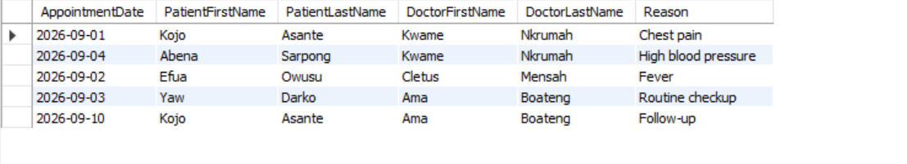
Query 4: Count how many appointments each doctor has
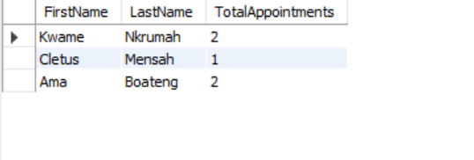
Query 5: Find all patients diagnosed with hypertension

Query 6: List all medications prescribed, with the patient who received them

Query 6: Find doctors who have more than 1 appointment

Query 7: Show department that have no doctors assigned yet
